**Renoir, Pierre-August** (1841-1919)

Pierre-August Renoir was a French painter and sculptor involved in the formation of Impressionism. As a pupil of the Swiss academic painter Charles Gleyre (1806-1874), whose studio he attended from 1861, Renoir met and befriended Claude Monet (1841-1926), Alfred Sisley (1839-1899), and Frédéric Bazille (1841-1870), pivotal members of the original Impressionist movement. In April 1862, at the age of twenty-one, he passed the examination to attend the Ecole Imperiale et Speciale des Beaux-Arts*.* In the summer of 1869, Renoir painted with Monet at La Grenouillère. The resulting pictures of Parisian leisure, painted outside in front of distinctly modern scenes, were decisive in Impressionism’s development. Although he met the artists who would become known as the Impressionists in 1861, he would not exhibit with them until 1874, when the first Impressionist exhibition was held in Paris. Renoir showed a large number of paintings in the first three exhibitions of the Impressionists. Throughout the 1870s, Renoir gained popularity with critics and secured the patronage of art dealers. Because of his disillusionment with the movement, Renoir chose not to exhibit at the final Impressionist exhibition in 1887. His later works adopted more classical themes through a return to the nude, rejecting the ‘modern life’ subjects of Impressionism.

Pierre-August Renoir was born in Limoges in 1841; his family moved to Paris in 1844. In 1854, he was apprenticed as a painter of porcelain. He also decorated fans and blinds with copies of Boucher and Watteau. After studying under Gleyre and at Ecole Imperiale et Speciale des Beaux-Arts*,* Renoir had success at the official Salon in the 1860s. However, his rejection in 1873 may have influenced his decision to play an active part in the first Impressionist group exhibition held in Paris during April-May 1874. Renoir’s *The Dancer* (1874) –a depiction of a young ballet dancer –and *La Loge* (1874) were shown in the first Impressionist exhibition. *La Loge,* praised by the art critic and writer Philippe Burty for its strong illusionism, represents a typically and recognisably modern subject of theatre, showing a fashionably dressed woman as the spectacle for a presumed male spectator. A male companion sits behind her, using opera glasses, leans to look above, towards a theatre box rather than down at the stage. Renoir’s *Dance at the Moulin de la Galette,* painted in 1876, was exhibited in the third Impressionist group exhibition of 1877. It is a directly observed painting of people dancing and socialising in Montmartre, praised for how well it captured the bohemian atmosphere of an open air dance and its realist depiction of Parisian life. The reviewers were relatively favourable towards his work; the excellence, attraction, and promise of the paintings exhibited in 1874 were recognised, but these same works were criticised for their sketchy quality and Renoir’s apparent confusion of the reality of his subjects with mere appearances and shadows. Renoir disliked the label ‘intransigent’, the other popular name for the Impressionists in the 1870s, which carried politically radical connotations.

By the end of the 1870s, Renoir was popular with critics and collectors. The support of the art dealer Paul Durand-Ruel allowed him financial security and the ability to travel. By the 1880s, Renoir had become increasingly disillusioned with the naturalism of Impressionism and did not exhibit at the final Impressionist exhibition of 1887. Renoir had become more uncertain of his own practice and aware of its limitations. The technique he had adopted in the mid-1870s of juxtaposing patches of sketchy colour characteristic of his landscapes and scenes of modern life and recreation, for instance in *La Place Clichy* of 1880, did not lend itself to his commissioned portraits, which required more traditional tonal modelling. Renoir’s sharply delineated paintings of bathers, begun in the early 1880s, signified a new departure in his practice; the mid-1880s was a period of experimentation. The concern of these new works – as demonstrated in his large painting *The Bathers,* first exhibited in May 1887 – is the ‘grandeur and eternal beauty’ of idealised images of women and a kind of naturalized femininity, rather than the contingent and ephemeral images characteristic of Impressionism. According to the painter Berthe Morisot (1841-1895), Renoir found in the female nude ‘one of the most essential forms of art’. He explored classical and mythological themes in his *The Judgment of Paris* of 1908 and 1913-14; this was antithetical to the Impressionist preoccupation with the fleeting experiences of modern life of the 1870s. In their emphatic and vivid subject matter, these works resist modernist valuations of art and instead link to a tradition in which the female nude metaphorically represents truth, beauty, and purity. Renoir joins Titian, Rubens, and Boucher in a celebration of female beauty and physical sensuality. Reviewers of the1985 exhibition *Renoir* at the Hayward Gallery, London focused on sensuality to describe these late works and the enjoyment of looking at them. The ‘timeless ideal of feminine beauty’ that writers found in Renoir’s paintings on the subject of the female nude became an opportunity to comment on contemporary sexual politics and femininity and, in some cases, to validate reactionary political values. Thus Renoir’s works, at different times and in different eras, have represented both a provocation against an artistic and cultural status quo and also a reaffirmation of traditional conceptions of art.

**Images:**

*The Large Bathers (1887)*

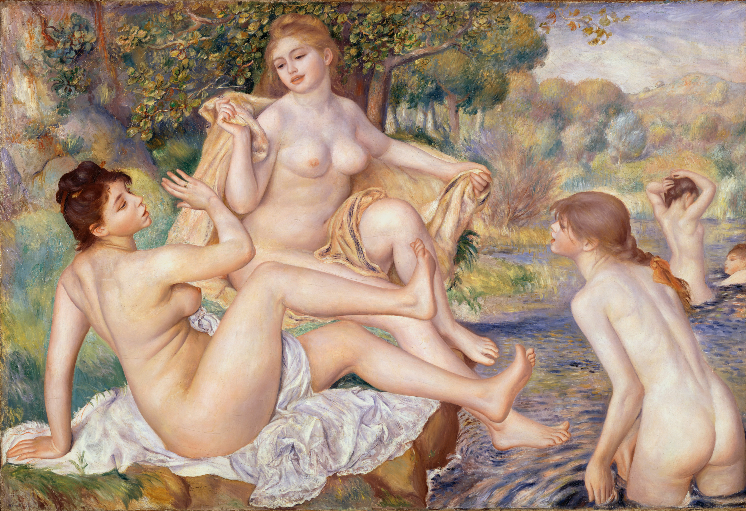

*The Large Bathers (1887)*

[http://www.philamuseum.org/collections/permanent/59196.html](https://owa.dur.ac.uk/owa/redir.aspx?C=oUo9wOgnX0-E5dHVk-zmxmFwZx9dSNEI5AIEQXzGYU4ODgSPq1JBR6PY2U3cLhpLezrdOtGn6Uo.&URL=http%3a%2f%2fwww.philamuseum.org%2fcollections%2fpermanent%2f59196.html) in the Philadelphia Museum of Art.

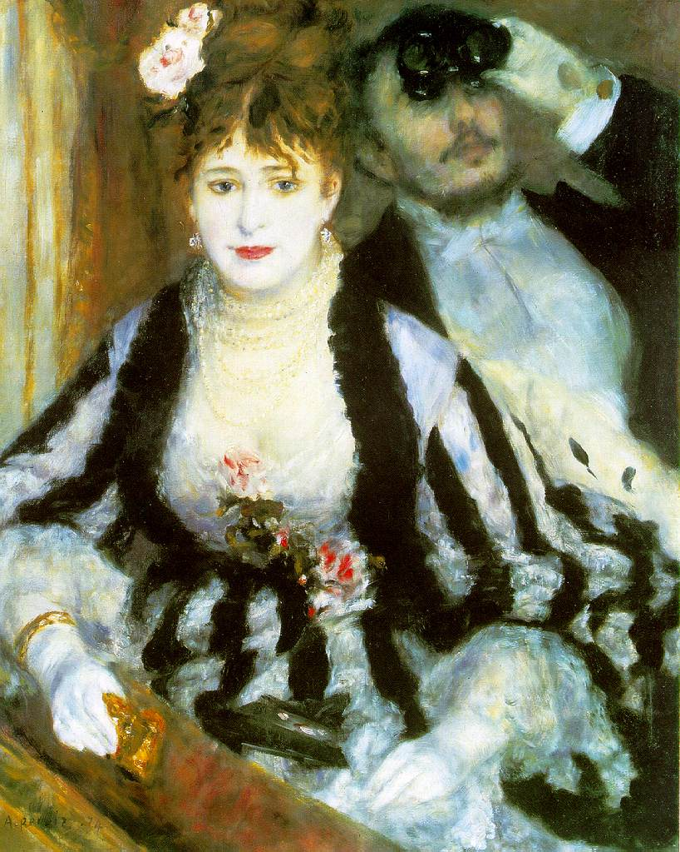

*La Loge (1874)*

[http://www.courtauldimages.com/image_details.php?image_id=167441](https://owa.dur.ac.uk/owa/redir.aspx?C=oUo9wOgnX0-E5dHVk-zmxmFwZx9dSNEI5AIEQXzGYU4ODgSPq1JBR6PY2U3cLhpLezrdOtGn6Uo.&URL=http%3a%2f%2fwww.courtauldimages.com%2fimage_details.php%3fimage_id%3d167441)

The webpage for the artwork is:

[http://www.courtauld.ac.uk/gallery/collections/paintings/imppostimp/renoir.shtml](https://owa.dur.ac.uk/owa/redir.aspx?C=oUo9wOgnX0-E5dHVk-zmxmFwZx9dSNEI5AIEQXzGYU4ODgSPq1JBR6PY2U3cLhpLezrdOtGn6Uo.&URL=http%3a%2f%2fwww.courtauld.ac.uk%2fgallery%2fcollections%2fpaintings%2fimppostimp%2frenoir.shtml)

**References and further reading**

Distel, A., and House, J. (1985) *Renoir*, exhib. cat. London: Hayward Gallery.

Nead, L. (1985) ‘Pleasing, Cheerful and Pretty’?: Sexual and Cultural Politics at the Hayward Gallery Renoir by Renoir, *Oxford Art Journal*, Vol. 8, No. 1, Caricature pp. 72-74.

Pollock, G. (2006) ’Modernity and the Spaces of Femininity’, *Vision and Difference: Feminism, femininity and the histories of art.* London and New York: Routledge.